### Our Vacation Album

This summer, my husband and I went on a 15 day trip on the Viking Prestige from Nuremberg to Oxford. We visited so many cities that I wanted to chronicle it all. Before we left on our trip, I made a vacation album with a page for each of the cities. I purchased the chipboard mini album design by Lori Whitlock from the Silhouette online store. I then created a blank post card using watercolor paper so I could draw using a variety of mediums like colored pencils, watercolor pencils, markers or just gluing paper cutouts on vacation. Every day, I brought my mini album and art supplies in a hanging cosmetic bag and created a post card for the city. We had plenty of time to do this because we usually travelled from the Viking Prestige ship to a city location. I would hang my art supplies in front of me on the bus and I would create my post card for the last location we had visited.  
  
Here is a picture of my mini album.

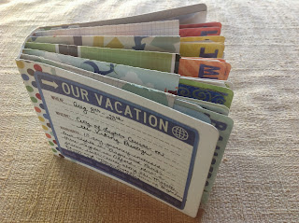

I created a page for each city that we visited. I used my Silhouette to cut out each city name. It was easy to do. Type a name, make a rectangular box underneath the name making sure that it overlaps the letters. Use the Weld feature to create an image that can be cut out as one piece.

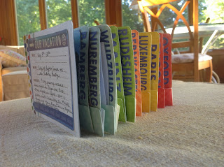

The mini album from Lori Whitlock did not include a pocketed page so I created one along with a template for the watercolor pages.

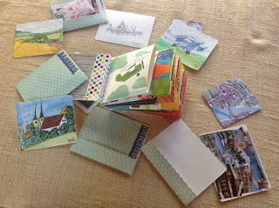

For the pocket page and the watercolor page, fold the scalloped edge paper in half and glue each side to the paper with the straight edge on the bottom to create a pocket. The watercolor paper has rounded edges and comes in two sizes. One for the front of the pocket so that the name of the city will show and the other to fit in the back. Each pocket can hold a few pieces of watercolor paper.

Please note, I did not copy any of Lori's work. I created these pages with measurements that I wanted for the watercolor pages and the pocket holder. The scallop on the pocket was created with circles that intersect. Here's how to do it...create a circle and duplicate as many times as you want, intersect the circles, cut the circles in half, delete the half of the circles that you do not want, edit select the entire image and point edit the lines to combine the red dots.

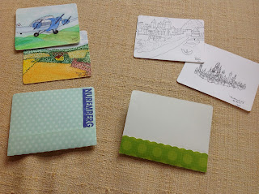

Here is a close up view of the pocket pages. The smaller watercolor pages are on the left. I created the scallop to go on the backside of the pocket for interest and the front side has a straight edge pocket.